Ideation Phase
Empathize & Discover

Date | 11 July 2026
Team ID
Project Name | House Rent Management System
Maximum Marks | 4 Marks

Empathy Map Canvas:
An empathy map is a simple, easy-to-digest visual that captures knowledge about a user’s behaviours and attitudes.

It is a useful tool to helps teams better understand their users.
Creating an effective solution requires understanding the true problem and the person who is experiencing it. The exercise of creating the map helps participants consider things from the user’s perspective along with his or her goals and challenges.
Example:

😊 SAYS
- I need a rental house within my budget.
- I want to compare different rental properties.
- I need accurate property information.
- I prefer booking a house online.
- I want a secure and reliable platform.

🤔 THINKS
- Is this property genuine?
- Is the rental price reasonable?
- Will the booking process be secure?
- Can I trust the property owner?
- Is there a better property available?

🚶 DOES
- Searches properties by location.
- Compares rental prices.
- Filters properties by type and budget.
- Views complete property details.
- Books suitable rental properties online.

❤️ FEELS
- Confused when information is incomplete.
- Frustrated while searching manually.
- Happy when suitable properties are found.
- Satisfied after successful booking.
- Confident using an easy and secure application.

😟 PAINS
- Difficult to find reliable rental properties.
- Too much time spent searching manually.
- Limited property information.
- Lack of centralized rental platforms.
- Difficulty comparing multiple properties.

🎯 GAINS
- Easy access to rental properties.
- Faster property search.
- Secure online booking.
- Time-saving process.
- Better decision-making through filters and property details.
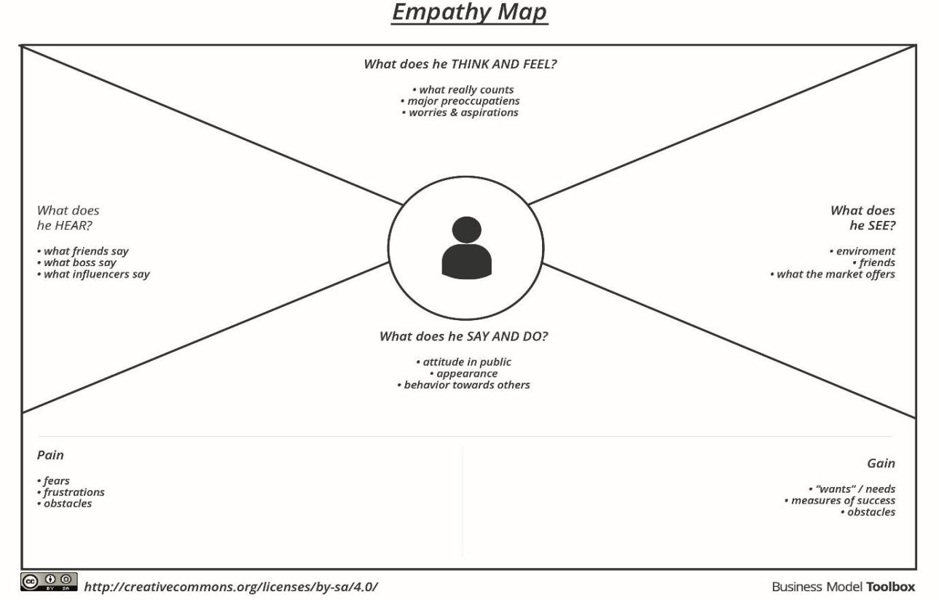

Example: House Rent Management System
